Assgnment8
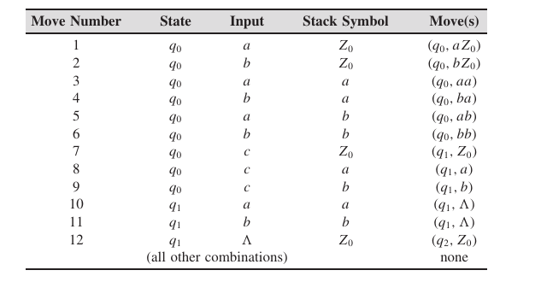
1. For the table shown above, trace the contents of the stack for the nput strings abbbba, abaaaa.
2. Give transition tables for PDAs accepting the following language.
{a ^{n} x | n ≥ 0, x ∈ {a, b}∗ and |x| ≤ n}.

3. Aa transition table is given for a PDA with initial state in the table below. q0 is the starting state and accepting state is q2 . Describe the language that is accepted.
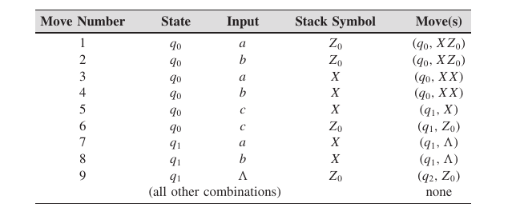
4. Show that every regular language can be accepted by a deterministic PDA M with only two states in which there are no #-transitions and no
symbols are ever removed from the stack.

5. Show that the following language can be accepted by a DPDA.
{xx ∼ | x ∈ {a, b}∗ } (where x ∼ means the string obtained from x by
changing a’s to b’s and b’s to a’s)

6. Consider the CFG G with productions
S → aB | bA | #
A → aS | bAA
B → bS | aBB
generating AeqB. Constuct the nondeterministic top-down PDA and the nondeterministic bottom-up PDA NB(G), and trace them for the
the input string aababb.

7. In each case below, show using the pumping lemma that the given
language is not a CFL.
a. L = {a ^{i} b ^{j} c ^{k} | i < j < k}
b. L = {a ^{2n} | n ≥ 0}
c. L = {x ∈ {a, b} ∗ | n_{b} (x) = n_{a} (x)²}
d. L = {x ∈ {a, b, c}∗ | n_{a} (x) = min {n_{b} (x), n_{c} (x)}}

8. Show that the given language is a CFL but that its complement is not.
{a ^{i} b^{j} c^{k} | i ≥ j or i ≥ k}

